3/30/2021

Abdelrahman Adel

Abdelrahman.adel.elsayed@gmail.com

AI Diploma

Assessment Two

Contents

Docker: 2

Definition: 2

Advantages: 2

Disadvantages: 2

Functionality: 2

Devops: 4

Definition: 4

Advantages: 4

Disadvantages: 4

Tools: 5

Ai Companies Egypt: 6

References 8

# Docker:

## Definition:

Docker is a platform which aims to simplify the process of running multiple software with different requirements on the same machine, Docker perform by making a virtual operating system in the form of containers, so that each container carries the required process table, network interfaces, dependencies and libraries needed to run the application. The first appearance of docker programming was on 2013, and it was written in Go programming language.

## Advantages:

* Supporting multiple applications with different requirements and dependencies to have the same host machine.
* Reducing the used disk space and memory used to perform the running process.
* Speeding up the machine bootup as the docker does not require creating standalone operating system like the virtual machines.
* Decreasing the cost of hardware.

## Disadvantages:

* The main disadvantage of docker is that the docker host hosts applications which have the same operating system as requirement.

## Functionality:

Docker Engine is the main responsible component of managing the docker functioning. It consists of three main components:

1. Server: which runs a manager called the docker daemon that is responsible of containers, images and data volumes creation and management.
2. Rest API: organize the communication between the docker server and application to ensure they perform correctly.
3. Client: a command line allowing the user to interact with the docker.

And the client has two important components:

1. Docker Image: template which carries the application and all it’s dependencies and libraries.
2. 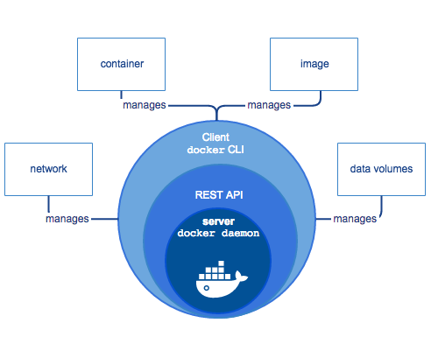Docker Container: Logical component which contain the dockers image and system kernel and run the image.

# Devops:

## Definition:

Devops is software production methodology, which tries to get rid of the limitations in the previous models like waterfall and agile model, by reducing the gap between the teams of the development and operations. It aims to fasten the process of software development during all the phases of software development life cycle. Using automated tools to turn the development process, testing, requirement gathering, analysis and software design faster than the traditional ways. It also aims to break down the process of development into small chunks of coding and testing, to produce a high performance, low cost, efficient and optimized software.

## Advantages:

* Reducing the software development time.
* Increasing the productivity of the company.
* Saving cost of maintenance.
* Improving the quality and reusability of the system components, by intensifying feedback.
* Improving the visibility of features developments to the client.
* Enhancing the communication and calibration between the company teams.

## Disadvantages:

* Might face challenges or fail if the organization culture does not coop with the aspects of devops, in cases where the company have a restrictive system of accessing the data for example.
* The difference of interests and the way the teams of operations and developers sees the software might affect the operation.
* The deep-seated companies, where the employees do not have the mentality of shifting roles is a huge draw back to the devops methodology.

## Tools:

* Slack: communication tool used between the teams to transfer data and to get support.
* Git: used in the phase of software building.
* Jenkins: automation server used for the continuous integration and delivery.
* 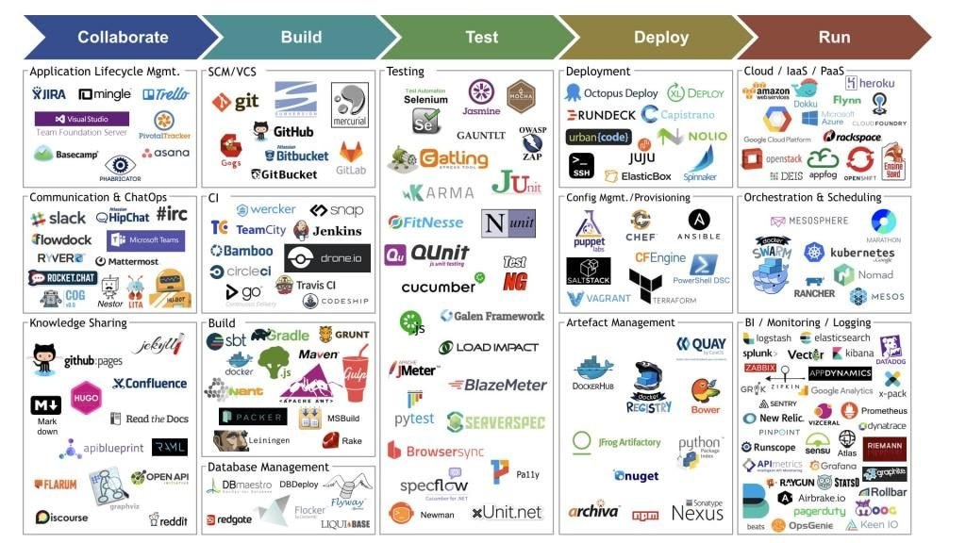Kubernetes: used to build server less functions to run on any cloud, ending the limitations of execution duration, languages availability and the code size.

# Ai Companies Egypt:

1. EPSILON AI

2. ABM Egypt

3. Adam

4. Advansy ESC

5. Affectiva

6. Agolo

7. Arqamfc

8. Ave labs

9. Avid beam

10. BADR

11. Bee Smart Payment Solutions

12. Botler

13. Cequens

14. Cognitev(Mena commerce)

15. Comiot

16. Crowd analyzer

17. Data Gear BI18. DLC

19. El menus

20. Elves

21. Heuro Labs

22. HUB 43

23. IBM Egypt

24. Incorta

25. InnoVision Systems

26. Itworx

27. Knowledge officer

28. Media Gate

29. Mendel

30. Microsoft ATLc

31. OMS

32. Optomatica

33. Oracle

34. Orange

35. Pixellion

36. Raisa Energy

37. RDI

38. Rology

39. Sadeem

40. Seeloz

41. Soho Square Solutions

42. Speakol

43. Sypron

44. Stratochem

45. Tactful

46. Tahrir news

47. TA Telecom

48. TayRec

49. Teradata

50. The D. GmbH

51. Tpay

52. Trendak

53. Trustious

54. Usy tech

55. Valeo

56. Vditory

57. Wego

58. WideBot

59. Wuzzuf

60. Xtrava

61. Yaoota!

# References

|  |  |
| --- | --- |
| [1] | Shahzan, "freeCodeCamp," 17 04 2020. [Online]. Available: https://www.freecodecamp.org/news/docker-simplified-96639a35ff36/. |
| [2] | E. AI, "https://epsiloneg.com/," Epsilon AI, [Online]. Available: https://epsiloneg.com/wp-content/uploads/2020/10/AI-Driven-Companies-in-Egypt.pdf. |
| [3] | D. A. S. A. (DASA), "DevOps Agile Skills Association (DASA)," 11 07 2019. [Online]. Available: https://www.devopsagileskills.org/dasa-and-devops/. |
| [4] | S. M. ,. L. E. L. ,. J. T. ,. a. T. M. Leah Riungu-Kalliosaari, "DevOps Adoption Benefits and Challenges," University of Helsinki, Finland, 2016. |
| [5] | A.Tintin, "Devopedia," 06 01 2020. [Online]. Available: https://devopedia.org/devops#qst-ans-5. |